The Gilded Age (including Westward Expansion)
1877-1898

The Transcontinental Railroad established a permanent link between the East and West coasts. This created new markets for the goods being produced as a result of industrialization. This led to the Gilded Age which gets it’s name from the wealth that is created during this time and the way of life this wealth supported. Although not everyone in this period enjoyed the privileges that wealth can provide.

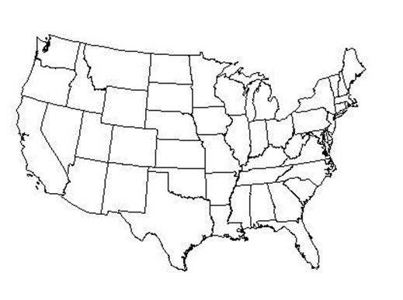

On the map above identify the following key areas during this time and explain why they were important:

- San Francisco/Angel Island

- Chicago

- New York/Ellis Island

© Created by Frisco ISD—Permission granted to reproduce for educational purposes. Not intended for sale.

The Gilded Age 1877-1898

(includes Westward Expansion)

3A 1. From 1877-1898, the US experienced many political changes—identify the changes below and explain why they were enacted:

Identify the following: | Explain why these were enacted:
Indian policies
Political Machines
Civil Service Reform
Beginnings of Populism
3B 2. What led to the following economic changes during this time period and how did they impact society?

What led to this? | How did this impact society?
Growth of Railroads
Farm issues
The Cattle Industry Boom

3B

3B

3D

15C
- What led to the following economic changes during this time period and how did they impact society?

What led to this? | How did this impact society?
Industrialization
Growth of Labor Unions
Rise of Entrepreneurship

- What are the pros and cons of big business?

Pros of Big Business | Cons of Big Business

- Why were immigrants optimistic about coming to America?

- What was the Chinese Exclusion Act of 1882?

3C 1. What social issues affected the following groups?

Women
Minorities
Children
Immigrants

3C 2. Define the following and explain their impact on social issues?

 | Definition | Impact
Urbanization
Social Gospel

3C 3. The era of industrialization was a time when some individuals became extremely wealthy. Some of these individuals used their wealth to help others. Identify examples:

Name of Individual | Example of Philanthropic Activities

15A 1. How did the Transcontinental Railroad affect the economy?

  - How did the Transcontinental Railroad and the Homestead Act lead to the close of the frontier?

15B

  - Define the following and explain how they altered the relationship between the Federal government and private business.

 | Definition | Relationship between federal government and private business.
Sherman Anti Trust Act
Interstate Commerce Act

12A

26B

27B

- Who settled on the Great Plains?

- How did settling on the Great Plains affect the environment?

- How did the U.S. government help immigrants and Native Americans assimilate into the American culture?

- Why did farmers (who settled out west) need new technologies?

- How did technological advancements in farming equipment help farmers?

Westward Expansion: Identify the following and explain their link to westward expan- sion.

- Promontory Point -

- Morrill Act -

- Manifest Destiny -

- Dawes Act

- bimetallism

- The Grange

Industrialization & Rise of Big Business: Identify the following and explain their link to industrialization and rise of big business.

- laissez-faire capitalism -

- investment capital-

- social Darwinism

- Bessemer process

- electricity

- robber barons

- monopolies

- Philanthropy

- graft

- collective bargaining

- patronage

- Interstate Commerce Act

- Sherman Antitrust Act

Immigration & Urbanization: Identify the following and explain their link to immigration and urbanization.

- Angel Island

- Ellis Island

- Assimilation

- Boss Tweed

